Natalie Cluck, Megan Fischer

April 21, 2017

CSCE 313-504

MP 7 Report

1. **Present a brief performance evaluation of your code. If there is a difference in performance from MP6, attempt to explain it. If the performance appears to have decreased, can it be justified as a necessary trade-off?**

The performance from MP6 was not very good. For MP7 our graphs were more consistent with values that we were expecting. The performance of MP7 was definitely a lot better than MP6. It is hard to compare the performance values of our MP6 and MP7 because our MP6 was not very accurate. I would go with our MP7 as being the more accurate because we had more time to work on it.

1. **Make two graphs for the performance of your client program with varying numbers of worker threads and varying size of request buffer (i.e. different values of “w” and “b”) for n = 10000. Discuss how performance is affected by each of them, and offer explanations for both.**
   * **Include b = 1 is among your data points.**
   * **Please don’t copy-past from your MP6 report, even if some of the answers you come up with are similar for MP7.**

The b value was set to 50 for the different values of w.

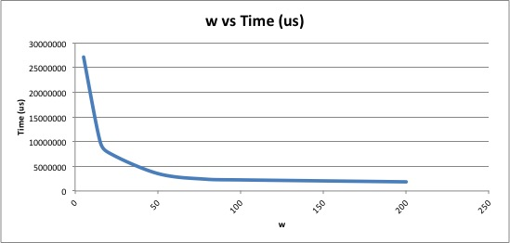

The time is takes to run is significantly decreased by the number of worker threads that need to be created.

The w value was set to 10 for the different values of b.

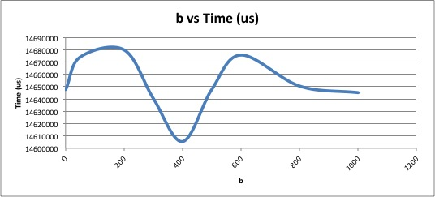

Our performance was not very consistent, but the difference for time was not a whole lot as the buffer size increased.

1. **Describe the platform that your data was gathered on and the operating system it was running. A simple description like “a Raspberry PI model B running Raspbian OS,” or “the CSE Linux server,” is sufficient. (Think of this as free points)**

I used the terminal on the Vocareum website. The command line says [ccc_v1_MmQ0M+95485@terminal_student_1 ~]. This was the easiest and fastest way for me to compile the code and gather time information because I have a Mac and can’t compile it on my personal computer. Vocareum is a web based operating system.